Group diseasd (1)
Reading images from "C:\Users\gehan\Documents\BOLD\HCV\analysis\Results\ALFF_FunImgARCW\ALFFMap_Sub001.nii" etc.

Image Files in the Group:
C:\Users\gehan\Documents\BOLD\HCV\analysis\Results\ALFF_FunImgARCW\ALFFMap_Sub001.nii
C:\Users\gehan\Documents\BOLD\HCV\analysis\Results\ALFF_FunImgARCW\ALFFMap_Sub0010.nii
C:\Users\gehan\Documents\BOLD\HCV\analysis\Results\ALFF_FunImgARCW\ALFFMap_Sub002.nii
C:\Users\gehan\Documents\BOLD\HCV\analysis\Results\ALFF_FunImgARCW\ALFFMap_Sub003.nii
C:\Users\gehan\Documents\BOLD\HCV\analysis\Results\ALFF_FunImgARCW\ALFFMap_Sub004.nii
C:\Users\gehan\Documents\BOLD\HCV\analysis\Results\ALFF_FunImgARCW\ALFFMap_Sub005.nii
C:\Users\gehan\Documents\BOLD\HCV\analysis\Results\ALFF_FunImgARCW\ALFFMap_Sub006.nii
C:\Users\gehan\Documents\BOLD\HCV\analysis\Results\ALFF_FunImgARCW\ALFFMap_Sub007.nii
C:\Users\gehan\Documents\BOLD\HCV\analysis\Results\ALFF_FunImgARCW\ALFFMap_Sub008.nii
C:\Users\gehan\Documents\BOLD\HCV\analysis\Results\ALFF_FunImgARCW\ALFFMap_Sub009.nii
C:\Users\gehan\Documents\BOLD\HCV\analysis\Results\ALFF_FunImgARCW\mALFFMap_Sub001.nii
C:\Users\gehan\Documents\BOLD\HCV\analysis\Results\ALFF_FunImgARCW\mALFFMap_Sub0010.nii
C:\Users\gehan\Documents\BOLD\HCV\analysis\Results\ALFF_FunImgARCW\mALFFMap_Sub002.nii
C:\Users\gehan\Documents\BOLD\HCV\analysis\Results\ALFF_FunImgARCW\mALFFMap_Sub003.nii
C:\Users\gehan\Documents\BOLD\HCV\analysis\Results\ALFF_FunImgARCW\mALFFMap_Sub004.nii
C:\Users\gehan\Documents\BOLD\HCV\analysis\Results\ALFF_FunImgARCW\mALFFMap_Sub005.nii
C:\Users\gehan\Documents\BOLD\HCV\analysis\Results\ALFF_FunImgARCW\mALFFMap_Sub006.nii
C:\Users\gehan\Documents\BOLD\HCV\analysis\Results\ALFF_FunImgARCW\mALFFMap_Sub007.nii
C:\Users\gehan\Documents\BOLD\HCV\analysis\Results\ALFF_FunImgARCW\mALFFMap_Sub008.nii
C:\Users\gehan\Documents\BOLD\HCV\analysis\Results\ALFF_FunImgARCW\mALFFMap_Sub009.nii
C:\Users\gehan\Documents\BOLD\HCV\analysis\Results\ALFF_FunImgARCW\zALFFMap_Sub001.nii
C:\Users\gehan\Documents\BOLD\HCV\analysis\Results\ALFF_FunImgARCW\zALFFMap_Sub0010.nii
C:\Users\gehan\Documents\BOLD\HCV\analysis\Results\ALFF_FunImgARCW\zALFFMap_Sub002.nii
C:\Users\gehan\Documents\BOLD\HCV\analysis\Results\ALFF_FunImgARCW\zALFFMap_Sub003.nii
C:\Users\gehan\Documents\BOLD\HCV\analysis\Results\ALFF_FunImgARCW\zALFFMap_Sub004.nii
C:\Users\gehan\Documents\BOLD\HCV\analysis\Results\ALFF_FunImgARCW\zALFFMap_Sub005.nii
C:\Users\gehan\Documents\BOLD\HCV\analysis\Results\ALFF_FunImgARCW\zALFFMap_Sub006.nii
C:\Users\gehan\Documents\BOLD\HCV\analysis\Results\ALFF_FunImgARCW\zALFFMap_Sub007.nii
C:\Users\gehan\Documents\BOLD\HCV\analysis\Results\ALFF_FunImgARCW\zALFFMap_Sub008.nii
C:\Users\gehan\Documents\BOLD\HCV\analysis\Results\ALFF_FunImgARCW\zALFFMap_Sub009.nii

Regression Calculating...
.........................................................................................................................DLH 0.012482 voxels^-3 before correcting for temporal DOF

FWHMx = 8.162475 voxels
FWHMy = 7.146388 voxels
FWHMz = 6.340592 voxels
FWHMx = 24.487426 mm
FWHMy = 21.439163 mm
FWHMz = 19.021776 mm
DLH = 0.012723
VOLUME = 1632
RESELS = 369.860754

Regression Calculation finished.

One Sample T Test Calculation finished.
(base 0)
This report is based on CUI Xu's xjview. (http://www.alivelearn.net/xjview/)
Revised by YAN Chao-Gan and ZHU Wei-Xuan 20091108: suitable for different Cluster Connectivity Criterion: surface connected, edge connected, corner connected.
Number of clusters found: 2
----------------------
Cluster 1
Number of voxels: 825
Peak MNI coordinate: 24 -24 30
Peak MNI coordinate region: // Right Cerebrum // Frontal Lobe // Sub-Gyral // White Matter // undefined // undefined
Peak intensity: 4.6831
# voxels structure
825 --TOTAL # VOXELS--
825 Right Cerebrum
823 White Matter
652 Sub-Gyral
613 Frontal Lobe
87 Parietal Lobe
79 Sub-lobar
75 Extra-Nuclear
34 Limbic Lobe
29 Cingulate Gyrus
24 Inferior Parietal Lobule
14 Precentral Gyrus
12 Temporal Lobe
9 Middle Frontal Gyrus
8 Postcentral Gyrus
6 Corpus Callosum
5 Anterior Cingulate
4 Insula
3 Superior Temporal Gyrus
2 Gray Matter
1 Medial Frontal Gyrus
1 Precuneus
1 brodmann area 13
1 brodmann area 9
1 Postcentral_R (aal)
----------------------
Cluster 2
Number of voxels: 807
Peak MNI coordinate: -27 9 21
Peak MNI coordinate region: // Left Cerebrum // Frontal Lobe // Sub-Gyral // White Matter // undefined // undefined
Peak intensity: 5.2969
# voxels structure
807 --TOTAL # VOXELS--
807 Left Cerebrum
806 White Matter
647 Sub-Gyral
594 Frontal Lobe
91 Parietal Lobe
72 Sub-lobar
68 Extra-Nuclear
33 Limbic Lobe
25 Inferior Parietal Lobule
24 Cingulate Gyrus
17 Temporal Lobe
15 Precentral Gyrus
10 Corpus Callosum
8 Anterior Cingulate
8 Postcentral Gyrus
6 Middle Frontal Gyrus
4 Insula
1 Gray Matter
1 Superior Frontal Gyrus
1 brodmann area 32
1 Superior Temporal Gyrus

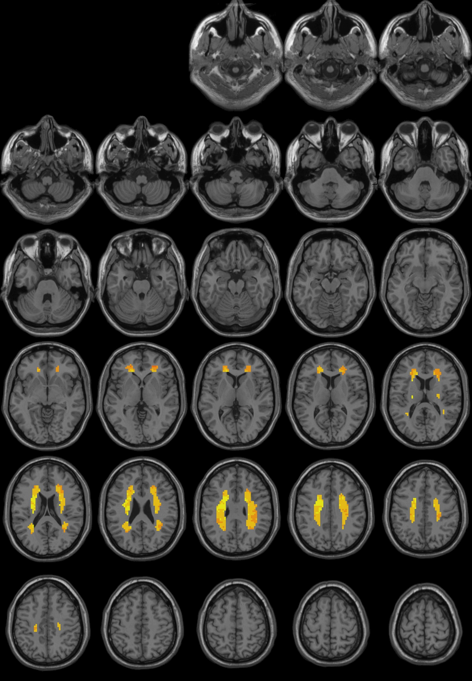

The same diseased group after treatment
Reading images from "C:\Users\gehan\Documents\BOLD\HCV\analysis_2\Results\ALFF_FunImgARCW\ALFFMap_Sub_001.nii" etc.

Image Files in the Group:
C:\Users\gehan\Documents\BOLD\HCV\analysis_2\Results\ALFF_FunImgARCW\ALFFMap_Sub_001.nii
C:\Users\gehan\Documents\BOLD\HCV\analysis_2\Results\ALFF_FunImgARCW\ALFFMap_Sub_0010.nii
C:\Users\gehan\Documents\BOLD\HCV\analysis_2\Results\ALFF_FunImgARCW\ALFFMap_Sub_002.nii
C:\Users\gehan\Documents\BOLD\HCV\analysis_2\Results\ALFF_FunImgARCW\ALFFMap_Sub_003.nii
C:\Users\gehan\Documents\BOLD\HCV\analysis_2\Results\ALFF_FunImgARCW\ALFFMap_Sub_004.nii
C:\Users\gehan\Documents\BOLD\HCV\analysis_2\Results\ALFF_FunImgARCW\ALFFMap_Sub_005.nii
C:\Users\gehan\Documents\BOLD\HCV\analysis_2\Results\ALFF_FunImgARCW\ALFFMap_Sub_006.nii
C:\Users\gehan\Documents\BOLD\HCV\analysis_2\Results\ALFF_FunImgARCW\ALFFMap_Sub_007.nii
C:\Users\gehan\Documents\BOLD\HCV\analysis_2\Results\ALFF_FunImgARCW\ALFFMap_Sub_008.nii
C:\Users\gehan\Documents\BOLD\HCV\analysis_2\Results\ALFF_FunImgARCW\ALFFMap_Sub_009.nii
C:\Users\gehan\Documents\BOLD\HCV\analysis_2\Results\ALFF_FunImgARCW\mALFFMap_Sub_001.nii
C:\Users\gehan\Documents\BOLD\HCV\analysis_2\Results\ALFF_FunImgARCW\mALFFMap_Sub_0010.nii
C:\Users\gehan\Documents\BOLD\HCV\analysis_2\Results\ALFF_FunImgARCW\mALFFMap_Sub_002.nii
C:\Users\gehan\Documents\BOLD\HCV\analysis_2\Results\ALFF_FunImgARCW\mALFFMap_Sub_003.nii
C:\Users\gehan\Documents\BOLD\HCV\analysis_2\Results\ALFF_FunImgARCW\mALFFMap_Sub_004.nii
C:\Users\gehan\Documents\BOLD\HCV\analysis_2\Results\ALFF_FunImgARCW\mALFFMap_Sub_005.nii
C:\Users\gehan\Documents\BOLD\HCV\analysis_2\Results\ALFF_FunImgARCW\mALFFMap_Sub_006.nii
C:\Users\gehan\Documents\BOLD\HCV\analysis_2\Results\ALFF_FunImgARCW\mALFFMap_Sub_007.nii
C:\Users\gehan\Documents\BOLD\HCV\analysis_2\Results\ALFF_FunImgARCW\mALFFMap_Sub_008.nii
C:\Users\gehan\Documents\BOLD\HCV\analysis_2\Results\ALFF_FunImgARCW\mALFFMap_Sub_009.nii
C:\Users\gehan\Documents\BOLD\HCV\analysis_2\Results\ALFF_FunImgARCW\zALFFMap_Sub_001.nii
C:\Users\gehan\Documents\BOLD\HCV\analysis_2\Results\ALFF_FunImgARCW\zALFFMap_Sub_0010.nii
C:\Users\gehan\Documents\BOLD\HCV\analysis_2\Results\ALFF_FunImgARCW\zALFFMap_Sub_002.nii
C:\Users\gehan\Documents\BOLD\HCV\analysis_2\Results\ALFF_FunImgARCW\zALFFMap_Sub_003.nii
C:\Users\gehan\Documents\BOLD\HCV\analysis_2\Results\ALFF_FunImgARCW\zALFFMap_Sub_004.nii
C:\Users\gehan\Documents\BOLD\HCV\analysis_2\Results\ALFF_FunImgARCW\zALFFMap_Sub_005.nii
C:\Users\gehan\Documents\BOLD\HCV\analysis_2\Results\ALFF_FunImgARCW\zALFFMap_Sub_006.nii
C:\Users\gehan\Documents\BOLD\HCV\analysis_2\Results\ALFF_FunImgARCW\zALFFMap_Sub_007.nii
C:\Users\gehan\Documents\BOLD\HCV\analysis_2\Results\ALFF_FunImgARCW\zALFFMap_Sub_008.nii
C:\Users\gehan\Documents\BOLD\HCV\analysis_2\Results\ALFF_FunImgARCW\zALFFMap_Sub_009.nii

Regression Calculating...
.........................................................................................................................DLH 0.010319 voxels^-3 before correcting for temporal DOF

FWHMx = 8.476247 voxels
FWHMy = 7.687670 voxels
FWHMz = 6.865806 voxels
FWHMx = 25.428742 mm
FWHMy = 23.063009 mm
FWHMz = 20.597417 mm
DLH = 0.010518
VOLUME = 1632
RESELS = 447.393658

Regression Calculation finished.

One Sample T Test Calculation finished.
This report is based on CUI Xu's xjview. (http://www.alivelearn.net/xjview/)
Revised by YAN Chao-Gan and ZHU Wei-Xuan 20091108: suitable for different Cluster Connectivity Criterion: surface connected, edge connected, corner connected.
Number of clusters found: 2
----------------------
Cluster 1
Number of voxels: 825
Peak MNI coordinate: 24 -15 18
Peak MNI coordinate region: // Right Cerebrum // Sub-lobar // Extra-Nuclear // White Matter // undefined // undefined
Peak intensity: 0.70843
# voxels structure
825 --TOTAL # VOXELS--
825 Right Cerebrum
823 White Matter
652 Sub-Gyral
613 Frontal Lobe
87 Parietal Lobe
79 Sub-lobar
75 Extra-Nuclear
34 Limbic Lobe
29 Cingulate Gyrus
24 Inferior Parietal Lobule
14 Precentral Gyrus
12 Temporal Lobe
9 Middle Frontal Gyrus
8 Postcentral Gyrus
6 Corpus Callosum
5 Anterior Cingulate
4 Insula
3 Superior Temporal Gyrus
2 Gray Matter
1 Medial Frontal Gyrus
1 Precuneus
1 brodmann area 13
1 brodmann area 9
1 Postcentral_R (aal)
----------------------
Cluster 2
Number of voxels: 807
Peak MNI coordinate: -15 -9 33
Peak MNI coordinate region: // Left Cerebrum // Limbic Lobe // Cingulate Gyrus // White Matter // undefined // undefined
Peak intensity: 0.79033
# voxels structure
807 --TOTAL # VOXELS--
807 Left Cerebrum
806 White Matter
647 Sub-Gyral
594 Frontal Lobe
91 Parietal Lobe
72 Sub-lobar
68 Extra-Nuclear
33 Limbic Lobe
25 Inferior Parietal Lobule
24 Cingulate Gyrus
17 Temporal Lobe
15 Precentral Gyrus
10 Corpus Callosum
8 Anterior Cingulate
8 Postcentral Gyrus
6 Middle Frontal Gyrus
4 Insula
1 Gray Matter
1 Superior Frontal Gyrus
1 brodmann area 32
1 Superior Temporal Gyrus

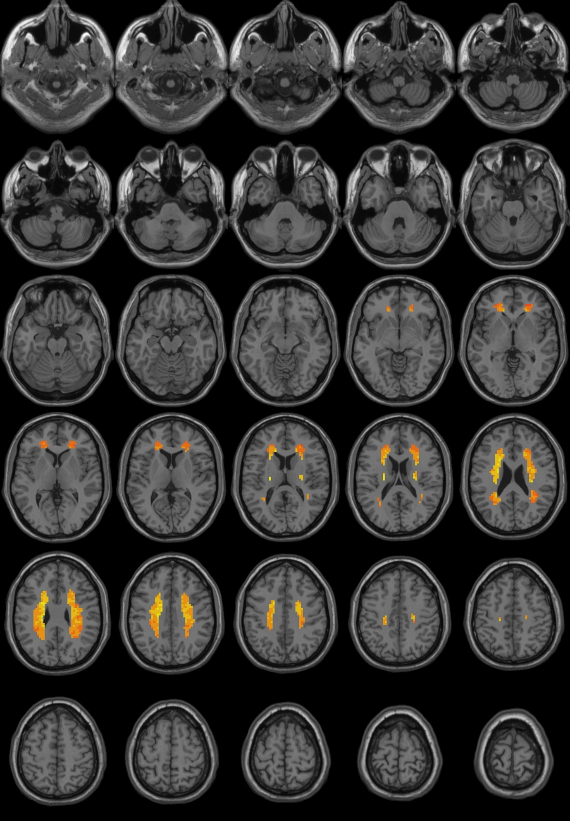

Paired T Test
Reading images from "C:\Users\gehan\Documents\BOLD\HCV\analysis\Results\ALFF_FunImgARCW\ALFFMap_Sub001.nii" etc.

Image Files in Condition 1:
C:\Users\gehan\Documents\BOLD\HCV\analysis\Results\ALFF_FunImgARCW\ALFFMap_Sub001.nii
C:\Users\gehan\Documents\BOLD\HCV\analysis\Results\ALFF_FunImgARCW\ALFFMap_Sub0010.nii
C:\Users\gehan\Documents\BOLD\HCV\analysis\Results\ALFF_FunImgARCW\ALFFMap_Sub002.nii
C:\Users\gehan\Documents\BOLD\HCV\analysis\Results\ALFF_FunImgARCW\ALFFMap_Sub003.nii
C:\Users\gehan\Documents\BOLD\HCV\analysis\Results\ALFF_FunImgARCW\ALFFMap_Sub004.nii
C:\Users\gehan\Documents\BOLD\HCV\analysis\Results\ALFF_FunImgARCW\ALFFMap_Sub005.nii
C:\Users\gehan\Documents\BOLD\HCV\analysis\Results\ALFF_FunImgARCW\ALFFMap_Sub006.nii
C:\Users\gehan\Documents\BOLD\HCV\analysis\Results\ALFF_FunImgARCW\ALFFMap_Sub007.nii
C:\Users\gehan\Documents\BOLD\HCV\analysis\Results\ALFF_FunImgARCW\ALFFMap_Sub008.nii
C:\Users\gehan\Documents\BOLD\HCV\analysis\Results\ALFF_FunImgARCW\ALFFMap_Sub009.nii
C:\Users\gehan\Documents\BOLD\HCV\analysis\Results\ALFF_FunImgARCW\mALFFMap_Sub001.nii
C:\Users\gehan\Documents\BOLD\HCV\analysis\Results\ALFF_FunImgARCW\mALFFMap_Sub0010.nii
C:\Users\gehan\Documents\BOLD\HCV\analysis\Results\ALFF_FunImgARCW\mALFFMap_Sub002.nii
C:\Users\gehan\Documents\BOLD\HCV\analysis\Results\ALFF_FunImgARCW\mALFFMap_Sub003.nii
C:\Users\gehan\Documents\BOLD\HCV\analysis\Results\ALFF_FunImgARCW\mALFFMap_Sub004.nii
C:\Users\gehan\Documents\BOLD\HCV\analysis\Results\ALFF_FunImgARCW\mALFFMap_Sub005.nii
C:\Users\gehan\Documents\BOLD\HCV\analysis\Results\ALFF_FunImgARCW\mALFFMap_Sub006.nii
C:\Users\gehan\Documents\BOLD\HCV\analysis\Results\ALFF_FunImgARCW\mALFFMap_Sub007.nii
C:\Users\gehan\Documents\BOLD\HCV\analysis\Results\ALFF_FunImgARCW\mALFFMap_Sub008.nii
C:\Users\gehan\Documents\BOLD\HCV\analysis\Results\ALFF_FunImgARCW\mALFFMap_Sub009.nii
C:\Users\gehan\Documents\BOLD\HCV\analysis\Results\ALFF_FunImgARCW\zALFFMap_Sub001.nii
C:\Users\gehan\Documents\BOLD\HCV\analysis\Results\ALFF_FunImgARCW\zALFFMap_Sub0010.nii
C:\Users\gehan\Documents\BOLD\HCV\analysis\Results\ALFF_FunImgARCW\zALFFMap_Sub002.nii
C:\Users\gehan\Documents\BOLD\HCV\analysis\Results\ALFF_FunImgARCW\zALFFMap_Sub003.nii
C:\Users\gehan\Documents\BOLD\HCV\analysis\Results\ALFF_FunImgARCW\zALFFMap_Sub004.nii
C:\Users\gehan\Documents\BOLD\HCV\analysis\Results\ALFF_FunImgARCW\zALFFMap_Sub005.nii
C:\Users\gehan\Documents\BOLD\HCV\analysis\Results\ALFF_FunImgARCW\zALFFMap_Sub006.nii
C:\Users\gehan\Documents\BOLD\HCV\analysis\Results\ALFF_FunImgARCW\zALFFMap_Sub007.nii
C:\Users\gehan\Documents\BOLD\HCV\analysis\Results\ALFF_FunImgARCW\zALFFMap_Sub008.nii
C:\Users\gehan\Documents\BOLD\HCV\analysis\Results\ALFF_FunImgARCW\zALFFMap_Sub009.nii

Reading images from "C:\Users\gehan\Documents\BOLD\HCV\analysis_2\Results\ALFF_FunImgARCW\ALFFMap_Sub_001.nii" etc.

Image Files in Condition 2:
C:\Users\gehan\Documents\BOLD\HCV\analysis_2\Results\ALFF_FunImgARCW\ALFFMap_Sub_001.nii
C:\Users\gehan\Documents\BOLD\HCV\analysis_2\Results\ALFF_FunImgARCW\ALFFMap_Sub_0010.nii
C:\Users\gehan\Documents\BOLD\HCV\analysis_2\Results\ALFF_FunImgARCW\ALFFMap_Sub_002.nii
C:\Users\gehan\Documents\BOLD\HCV\analysis_2\Results\ALFF_FunImgARCW\ALFFMap_Sub_003.nii
C:\Users\gehan\Documents\BOLD\HCV\analysis_2\Results\ALFF_FunImgARCW\ALFFMap_Sub_004.nii
C:\Users\gehan\Documents\BOLD\HCV\analysis_2\Results\ALFF_FunImgARCW\ALFFMap_Sub_005.nii
C:\Users\gehan\Documents\BOLD\HCV\analysis_2\Results\ALFF_FunImgARCW\ALFFMap_Sub_006.nii
C:\Users\gehan\Documents\BOLD\HCV\analysis_2\Results\ALFF_FunImgARCW\ALFFMap_Sub_007.nii
C:\Users\gehan\Documents\BOLD\HCV\analysis_2\Results\ALFF_FunImgARCW\ALFFMap_Sub_008.nii
C:\Users\gehan\Documents\BOLD\HCV\analysis_2\Results\ALFF_FunImgARCW\ALFFMap_Sub_009.nii
C:\Users\gehan\Documents\BOLD\HCV\analysis_2\Results\ALFF_FunImgARCW\mALFFMap_Sub_001.nii
C:\Users\gehan\Documents\BOLD\HCV\analysis_2\Results\ALFF_FunImgARCW\mALFFMap_Sub_0010.nii
C:\Users\gehan\Documents\BOLD\HCV\analysis_2\Results\ALFF_FunImgARCW\mALFFMap_Sub_002.nii
C:\Users\gehan\Documents\BOLD\HCV\analysis_2\Results\ALFF_FunImgARCW\mALFFMap_Sub_003.nii
C:\Users\gehan\Documents\BOLD\HCV\analysis_2\Results\ALFF_FunImgARCW\mALFFMap_Sub_004.nii
C:\Users\gehan\Documents\BOLD\HCV\analysis_2\Results\ALFF_FunImgARCW\mALFFMap_Sub_005.nii
C:\Users\gehan\Documents\BOLD\HCV\analysis_2\Results\ALFF_FunImgARCW\mALFFMap_Sub_006.nii
C:\Users\gehan\Documents\BOLD\HCV\analysis_2\Results\ALFF_FunImgARCW\mALFFMap_Sub_007.nii
C:\Users\gehan\Documents\BOLD\HCV\analysis_2\Results\ALFF_FunImgARCW\mALFFMap_Sub_008.nii
C:\Users\gehan\Documents\BOLD\HCV\analysis_2\Results\ALFF_FunImgARCW\mALFFMap_Sub_009.nii
C:\Users\gehan\Documents\BOLD\HCV\analysis_2\Results\ALFF_FunImgARCW\zALFFMap_Sub_001.nii
C:\Users\gehan\Documents\BOLD\HCV\analysis_2\Results\ALFF_FunImgARCW\zALFFMap_Sub_0010.nii
C:\Users\gehan\Documents\BOLD\HCV\analysis_2\Results\ALFF_FunImgARCW\zALFFMap_Sub_002.nii
C:\Users\gehan\Documents\BOLD\HCV\analysis_2\Results\ALFF_FunImgARCW\zALFFMap_Sub_003.nii
C:\Users\gehan\Documents\BOLD\HCV\analysis_2\Results\ALFF_FunImgARCW\zALFFMap_Sub_004.nii
C:\Users\gehan\Documents\BOLD\HCV\analysis_2\Results\ALFF_FunImgARCW\zALFFMap_Sub_005.nii
C:\Users\gehan\Documents\BOLD\HCV\analysis_2\Results\ALFF_FunImgARCW\zALFFMap_Sub_006.nii

C:\Users\gehan\Documents\BOLD\HCV\analysis_2\Results\ALFF_FunImgARCW\zALFFMap_Sub_007.nii
C:\Users\gehan\Documents\BOLD\HCV\analysis_2\Results\ALFF_FunImgARCW\zALFFMap_Sub_008.nii
C:\Users\gehan\Documents\BOLD\HCV\analysis_2\Results\ALFF_FunImgARCW\zALFFMap_Sub_009.nii
Regression Calculating...
.........................................................................................................................DLH 0.348603 voxels^-3 before correcting for temporal DOF

FWHMx = 2.663974 voxels
FWHMy = 2.382312 voxels
FWHMz = 2.086742 voxels
FWHMx = 7.991921 mm
FWHMy = 7.146936 mm
FWHMz = 6.260225 mm
DLH = 0.355338
VOLUME = 1632
RESELS = 13.243331

Regression Calculation finished.

Paired T Test Calculation finished.
....................................................................... This report is based on CUI Xu's xjview. (http://www.alivelearn.net/xjview/)
Revised by YAN Chao-Gan and ZHU Wei-Xuan 20091108: suitable for different Cluster Connectivity Criterion: surface connected, edge connected, corner connected.
Number of clusters found: 2
----------------------
Cluster 1
Number of voxels: 825
Peak MNI coordinate: 27 3 21
Peak MNI coordinate region: // Right Cerebrum // Sub-lobar // Extra-Nuclear // White Matter // undefined // undefined
Peak intensity: 0.40089
# voxels structure
825 --TOTAL # VOXELS--
825 Right Cerebrum
823 White Matter
652 Sub-Gyral
613 Frontal Lobe
87 Parietal Lobe
79 Sub-lobar
75 Extra-Nuclear
34 Limbic Lobe
29 Cingulate Gyrus
24 Inferior Parietal Lobule
14 Precentral Gyrus
12 Temporal Lobe
9 Middle Frontal Gyrus
8 Postcentral Gyrus
6 Corpus Callosum
5 Anterior Cingulate
4 Insula
3 Superior Temporal Gyrus
2 Gray Matter
1 Medial Frontal Gyrus
1 Precuneus
1 brodmann area 13
1 brodmann area 9
1 Postcentral_R (aal)
----------------------
Cluster 2
Number of voxels: 807
Peak MNI coordinate: -33 -3 24
Peak MNI coordinate region: // Left Cerebrum // Frontal Lobe // Sub-Gyral // White Matter // undefined // undefined
Peak intensity: 0.55341
# voxels structure
807 --TOTAL # VOXELS--
807 Left Cerebrum
806 White Matter
647 Sub-Gyral
594 Frontal Lobe
91 Parietal Lobe
72 Sub-lobar
68 Extra-Nuclear
33 Limbic Lobe
25 Inferior Parietal Lobule
24 Cingulate Gyrus
17 Temporal Lobe
15 Precentral Gyrus
10 Corpus Callosum
8 Anterior Cingulate
8 Postcentral Gyrus
6 Middle Frontal Gyrus
4 Insula
1 Gray Matter
1 Superior Frontal Gyrus
1 brodmann area 32
1 Superior Temporal Gyrus

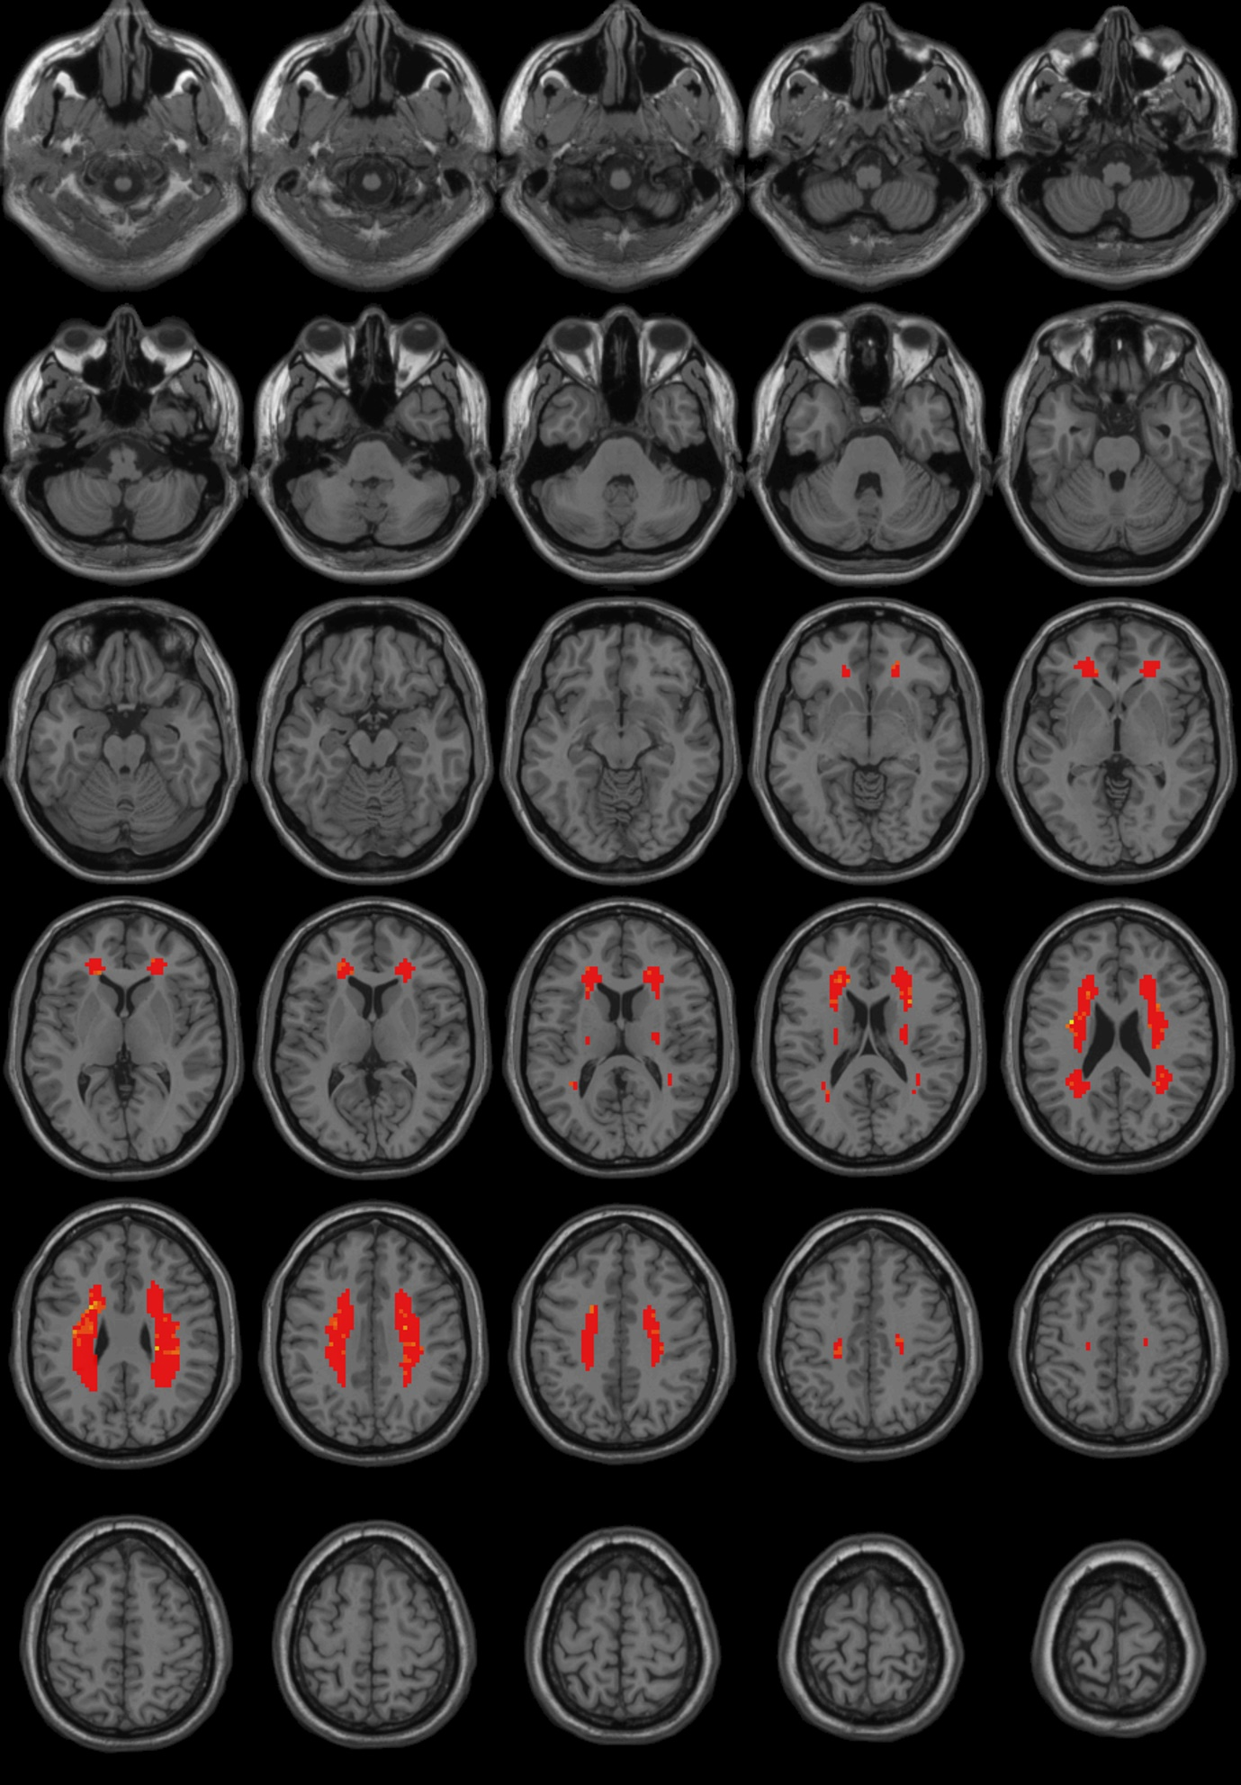

This report is based on CUI Xu's xjview. (http://www.alivelearn.net/xjview/)
Revised by YAN Chao-Gan and ZHU Wei-Xuan 20091108: suitable for different Cluster Connectivity Criterion: surface connected, edge connected, corner connected.
Number of clusters found: 10
----------------------
Cluster 1
Number of voxels: 509
Peak MNI coordinate: 24 -9 33
Peak MNI coordinate region: // Right Cerebrum // Frontal Lobe // Sub-Gyral // White Matter // undefined // undefined
Peak intensity: -3.1039
# voxels structure
509 --TOTAL # VOXELS--
509 Right Cerebrum
507 White Matter
419 Frontal Lobe
413 Sub-Gyral
41 Parietal Lobe
37 Sub-lobar
34 Extra-Nuclear
20 Inferior Parietal Lobule
13 Precentral Gyrus
12 Limbic Lobe
10 Cingulate Gyrus
7 Postcentral Gyrus
6 Middle Frontal Gyrus
4 Corpus Callosum
3 Insula
2 Anterior Cingulate
2 Gray Matter
1 brodmann area 13
1 brodmann area 9
1 Medial Frontal Gyrus
----------------------
Cluster 2
Number of voxels: 175
Peak MNI coordinate: -18 36 -3
Peak MNI coordinate region: // Left Cerebrum // Frontal Lobe // Sub-Gyral // White Matter // undefined // undefined
Peak intensity: -2.7642
# voxels structure
175 --TOTAL # VOXELS--
175 Left Cerebrum
174 White Matter
152 Frontal Lobe
147 Sub-Gyral
13 Extra-Nuclear
13 Sub-lobar
10 Limbic Lobe
6 Cingulate Gyrus
5 Middle Frontal Gyrus
4 Anterior Cingulate
1 Gray Matter
1 brodmann area 32
1 Corpus Callosum
----------------------
Cluster 3
Number of voxels: 162
Peak MNI coordinate: -30 -21 33
Peak MNI coordinate region: // Left Cerebrum // Frontal Lobe // Sub-Gyral // White Matter // undefined // undefined
Peak intensity: -2.4448
# voxels structure
162 --TOTAL # VOXELS--
162 White Matter
162 Left Cerebrum
143 Sub-Gyral
104 Frontal Lobe
48 Parietal Lobe
17 Inferior Parietal Lobule
8 Temporal Lobe
2 Sub-lobar
2 Extra-Nuclear
----------------------
Cluster 4
Number of voxels: 4
Peak MNI coordinate: 36 -42 18
Peak MNI coordinate region: // Right Cerebrum // Sub-lobar // Insula // White Matter // undefined // undefined
Peak intensity: -1.1556
# voxels structure
4 --TOTAL # VOXELS--
4 White Matter
4 Right Cerebrum
2 Temporal Lobe
2 Sub-lobar
2 Superior Temporal Gyrus
1 Extra-Nuclear
1 Insula
----------------------
Cluster 5
Number of voxels: 3
Peak MNI coordinate: 33 -54 21
Peak MNI coordinate region: // Right Cerebrum // Temporal Lobe // Sub-Gyral // White Matter // undefined // undefined
Peak intensity: -0.61211
# voxels structure
3 --TOTAL # VOXELS--
3 Sub-Gyral
3 Temporal Lobe
3 White Matter
3 Right Cerebrum
----------------------
Cluster 6
Number of voxels: 1
Peak MNI coordinate: 33 -39 21
Peak MNI coordinate region: // Right Cerebrum // Parietal Lobe // Sub-Gyral // White Matter // undefined // undefined
Peak intensity: -1.0926
# voxels structure
1 --TOTAL # VOXELS--
1 Right Cerebrum
1 Sub-Gyral
1 White Matter
1 Parietal Lobe
----------------------
Cluster 7
Number of voxels: 2
Peak MNI coordinate: -24 -12 21
Peak MNI coordinate region: // Left Cerebrum // Sub-lobar // Extra-Nuclear // White Matter // undefined // undefined
Peak intensity: -0.096116
# voxels structure
2 --TOTAL # VOXELS--
2 Sub-lobar
2 White Matter
2 Left Cerebrum
1 Extra-Nuclear
1 Insula
----------------------
Cluster 8
Number of voxels: 1
Peak MNI coordinate: -30 -18 24
Peak MNI coordinate region: // Left Cerebrum // Sub-lobar // Extra-Nuclear // White Matter // undefined // undefined
Peak intensity: -0.079859
# voxels structure
1 --TOTAL # VOXELS--
1 Left Cerebrum
1 Sub-lobar
1 White Matter
1 Extra-Nuclear
----------------------
Cluster 9
Number of voxels: 1
Peak MNI coordinate: -18 9 27
Peak MNI coordinate region: // Left Cerebrum // Frontal Lobe // Sub-Gyral // White Matter // undefined // undefined
Peak intensity: -0.24776
# voxels structure
1 --TOTAL # VOXELS--
1 Left Cerebrum
1 Sub-Gyral
1 White Matter
1 Frontal Lobe
----------------------
Cluster 10
Number of voxels: 1
Peak MNI coordinate: -36 -18 30
Peak MNI coordinate region: // Left Cerebrum // Frontal Lobe // Postcentral Gyrus // White Matter // undefined // undefined
Peak intensity: -0.33472
# voxels structure
1 --TOTAL # VOXELS--
1 Left Cerebrum
1 Postcentral Gyrus
1 White Matter
1 Frontal Lobe

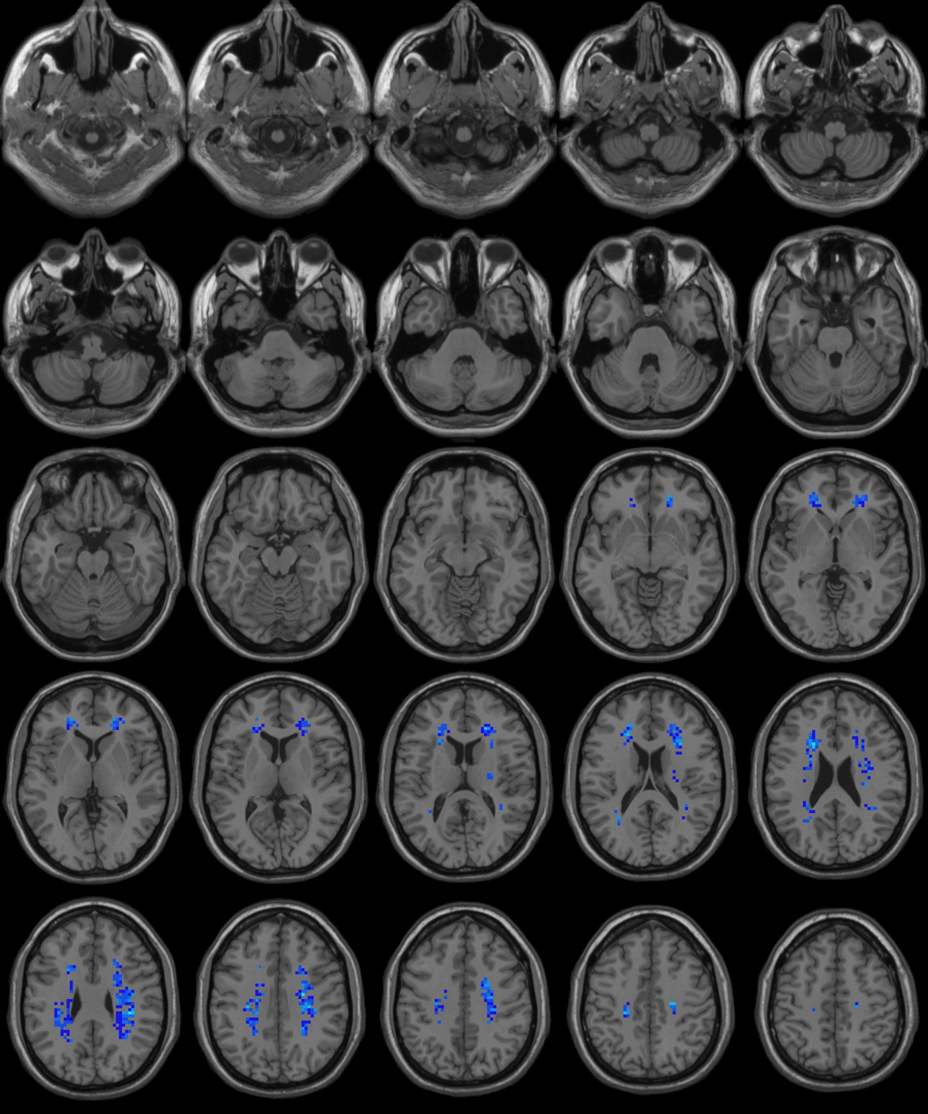

Patients vs control
Reading images from "C:\Users\gehan\Documents\BOLD\HCV\analysis\Results\ALFF_FunImgARCW\ALFFMap_Sub001.nii" etc.

Image Files in Group 1:
C:\Users\gehan\Documents\BOLD\HCV\analysis\Results\ALFF_FunImgARCW\ALFFMap_Sub001.nii
C:\Users\gehan\Documents\BOLD\HCV\analysis\Results\ALFF_FunImgARCW\ALFFMap_Sub0010.nii
C:\Users\gehan\Documents\BOLD\HCV\analysis\Results\ALFF_FunImgARCW\ALFFMap_Sub002.nii
C:\Users\gehan\Documents\BOLD\HCV\analysis\Results\ALFF_FunImgARCW\ALFFMap_Sub003.nii
C:\Users\gehan\Documents\BOLD\HCV\analysis\Results\ALFF_FunImgARCW\ALFFMap_Sub004.nii
C:\Users\gehan\Documents\BOLD\HCV\analysis\Results\ALFF_FunImgARCW\ALFFMap_Sub005.nii
C:\Users\gehan\Documents\BOLD\HCV\analysis\Results\ALFF_FunImgARCW\ALFFMap_Sub006.nii
C:\Users\gehan\Documents\BOLD\HCV\analysis\Results\ALFF_FunImgARCW\ALFFMap_Sub007.nii
C:\Users\gehan\Documents\BOLD\HCV\analysis\Results\ALFF_FunImgARCW\ALFFMap_Sub008.nii
C:\Users\gehan\Documents\BOLD\HCV\analysis\Results\ALFF_FunImgARCW\ALFFMap_Sub009.nii
C:\Users\gehan\Documents\BOLD\HCV\analysis\Results\ALFF_FunImgARCW\mALFFMap_Sub001.nii
C:\Users\gehan\Documents\BOLD\HCV\analysis\Results\ALFF_FunImgARCW\mALFFMap_Sub0010.nii
C:\Users\gehan\Documents\BOLD\HCV\analysis\Results\ALFF_FunImgARCW\mALFFMap_Sub002.nii
C:\Users\gehan\Documents\BOLD\HCV\analysis\Results\ALFF_FunImgARCW\mALFFMap_Sub003.nii
C:\Users\gehan\Documents\BOLD\HCV\analysis\Results\ALFF_FunImgARCW\mALFFMap_Sub004.nii
C:\Users\gehan\Documents\BOLD\HCV\analysis\Results\ALFF_FunImgARCW\mALFFMap_Sub005.nii
C:\Users\gehan\Documents\BOLD\HCV\analysis\Results\ALFF_FunImgARCW\mALFFMap_Sub006.nii
C:\Users\gehan\Documents\BOLD\HCV\analysis\Results\ALFF_FunImgARCW\mALFFMap_Sub007.nii
C:\Users\gehan\Documents\BOLD\HCV\analysis\Results\ALFF_FunImgARCW\mALFFMap_Sub008.nii
C:\Users\gehan\Documents\BOLD\HCV\analysis\Results\ALFF_FunImgARCW\mALFFMap_Sub009.nii
C:\Users\gehan\Documents\BOLD\HCV\analysis\Results\ALFF_FunImgARCW\zALFFMap_Sub001.nii
C:\Users\gehan\Documents\BOLD\HCV\analysis\Results\ALFF_FunImgARCW\zALFFMap_Sub0010.nii
C:\Users\gehan\Documents\BOLD\HCV\analysis\Results\ALFF_FunImgARCW\zALFFMap_Sub002.nii
C:\Users\gehan\Documents\BOLD\HCV\analysis\Results\ALFF_FunImgARCW\zALFFMap_Sub003.nii
C:\Users\gehan\Documents\BOLD\HCV\analysis\Results\ALFF_FunImgARCW\zALFFMap_Sub004.nii
C:\Users\gehan\Documents\BOLD\HCV\analysis\Results\ALFF_FunImgARCW\zALFFMap_Sub005.nii
C:\Users\gehan\Documents\BOLD\HCV\analysis\Results\ALFF_FunImgARCW\zALFFMap_Sub006.nii
C:\Users\gehan\Documents\BOLD\HCV\analysis\Results\ALFF_FunImgARCW\zALFFMap_Sub007.nii
C:\Users\gehan\Documents\BOLD\HCV\analysis\Results\ALFF_FunImgARCW\zALFFMap_Sub008.nii
C:\Users\gehan\Documents\BOLD\HCV\analysis\Results\ALFF_FunImgARCW\zALFFMap_Sub009.nii

Reading images from "C:\Users\gehan\Documents\BOLD\control\analysis\Results\ALFF_FunImgARCW\ALFFMap_Sub001.nii" etc.

Image Files in Group 2:
C:\Users\gehan\Documents\BOLD\control\analysis\Results\ALFF_FunImgARCW\ALFFMap_Sub001.nii
C:\Users\gehan\Documents\BOLD\control\analysis\Results\ALFF_FunImgARCW\ALFFMap_Sub002.nii
C:\Users\gehan\Documents\BOLD\control\analysis\Results\ALFF_FunImgARCW\ALFFMap_Sub003.nii
C:\Users\gehan\Documents\BOLD\control\analysis\Results\ALFF_FunImgARCW\ALFFMap_Sub004.nii
C:\Users\gehan\Documents\BOLD\control\analysis\Results\ALFF_FunImgARCW\ALFFMap_Sub005.nii
C:\Users\gehan\Documents\BOLD\control\analysis\Results\ALFF_FunImgARCW\ALFFMap_Sub006.nii
C:\Users\gehan\Documents\BOLD\control\analysis\Results\ALFF_FunImgARCW\ALFFMap_Sub007.nii
C:\Users\gehan\Documents\BOLD\control\analysis\Results\ALFF_FunImgARCW\ALFFMap_Sub008.nii
C:\Users\gehan\Documents\BOLD\control\analysis\Results\ALFF_FunImgARCW\mALFFMap_Sub001.nii
C:\Users\gehan\Documents\BOLD\control\analysis\Results\ALFF_FunImgARCW\mALFFMap_Sub002.nii
C:\Users\gehan\Documents\BOLD\control\analysis\Results\ALFF_FunImgARCW\mALFFMap_Sub003.nii
C:\Users\gehan\Documents\BOLD\control\analysis\Results\ALFF_FunImgARCW\mALFFMap_Sub004.nii
C:\Users\gehan\Documents\BOLD\control\analysis\Results\ALFF_FunImgARCW\mALFFMap_Sub005.nii
C:\Users\gehan\Documents\BOLD\control\analysis\Results\ALFF_FunImgARCW\mALFFMap_Sub006.nii
C:\Users\gehan\Documents\BOLD\control\analysis\Results\ALFF_FunImgARCW\mALFFMap_Sub007.nii
C:\Users\gehan\Documents\BOLD\control\analysis\Results\ALFF_FunImgARCW\mALFFMap_Sub008.nii
C:\Users\gehan\Documents\BOLD\control\analysis\Results\ALFF_FunImgARCW\zALFFMap_Sub001.nii
C:\Users\gehan\Documents\BOLD\control\analysis\Results\ALFF_FunImgARCW\zALFFMap_Sub002.nii
C:\Users\gehan\Documents\BOLD\control\analysis\Results\ALFF_FunImgARCW\zALFFMap_Sub003.nii
C:\Users\gehan\Documents\BOLD\control\analysis\Results\ALFF_FunImgARCW\zALFFMap_Sub004.nii
C:\Users\gehan\Documents\BOLD\control\analysis\Results\ALFF_FunImgARCW\zALFFMap_Sub005.nii
C:\Users\gehan\Documents\BOLD\control\analysis\Results\ALFF_FunImgARCW\zALFFMap_Sub006.nii
C:\Users\gehan\Documents\BOLD\control\analysis\Results\ALFF_FunImgARCW\zALFFMap_Sub007.nii
C:\Users\gehan\Documents\BOLD\control\analysis\Results\ALFF_FunImgARCW\zALFFMap_Sub008.nii

Regression Calculating...
.........................................................................................................................DLH 0.006693 voxels^-3 before correcting for temporal DOF

FWHMx = 10.157212 voxels
FWHMy = 8.637466 voxels
FWHMz = 7.862096 voxels
FWHMx = 30.471636 mm
FWHMy = 25.912397 mm
FWHMz = 23.586289 mm
DLH = 0.006762
VOLUME = 1632
RESELS = 689.761911

Regression Calculation finished.

Two Sample T Test Calculation finished.
This report is based on CUI Xu's xjview. (http://www.alivelearn.net/xjview/)
Revised by YAN Chao-Gan and ZHU Wei-Xuan 20091108: suitable for different Cluster Connectivity Criterion: surface connected, edge connected, corner connected.
Number of clusters found: 2
----------------------
Cluster 1
Number of voxels: 824
Peak MNI coordinate: 24 39 -3
Peak MNI coordinate region: // Right Cerebrum // Frontal Lobe // Middle Frontal Gyrus // White Matter // undefined // undefined
Peak intensity: 0.039004
# voxels structure
824 --TOTAL # VOXELS--
824 Right Cerebrum
822 White Matter
652 Sub-Gyral
613 Frontal Lobe
87 Parietal Lobe
79 Sub-lobar
75 Extra-Nuclear
33 Limbic Lobe
29 Cingulate Gyrus
24 Inferior Parietal Lobule
14 Precentral Gyrus
12 Temporal Lobe
9 Middle Frontal Gyrus
8 Postcentral Gyrus
6 Corpus Callosum
4 Insula
4 Anterior Cingulate
3 Superior Temporal Gyrus
2 Gray Matter
1 Medial Frontal Gyrus
1 Precuneus
1 brodmann area 13
1 brodmann area 9
1 Postcentral_R (aal)
----------------------
Cluster 2
Number of voxels: 807
Peak MNI coordinate: -24 36 3
Peak MNI coordinate region: // Left Cerebrum // Frontal Lobe // Sub-Gyral // White Matter // undefined // undefined
Peak intensity: 0.02885
# voxels structure
807 --TOTAL # VOXELS--
807 Left Cerebrum
806 White Matter
647 Sub-Gyral
594 Frontal Lobe
91 Parietal Lobe
72 Sub-lobar
68 Extra-Nuclear
33 Limbic Lobe
25 Inferior Parietal Lobule
24 Cingulate Gyrus
17 Temporal Lobe
15 Precentral Gyrus
10 Corpus Callosum
8 Anterior Cingulate
8 Postcentral Gyrus
6 Middle Frontal Gyrus
4 Insula
1 Gray Matter
1 Superior Frontal Gyrus
1 brodmann area 32
1 Superior Temporal Gyrus
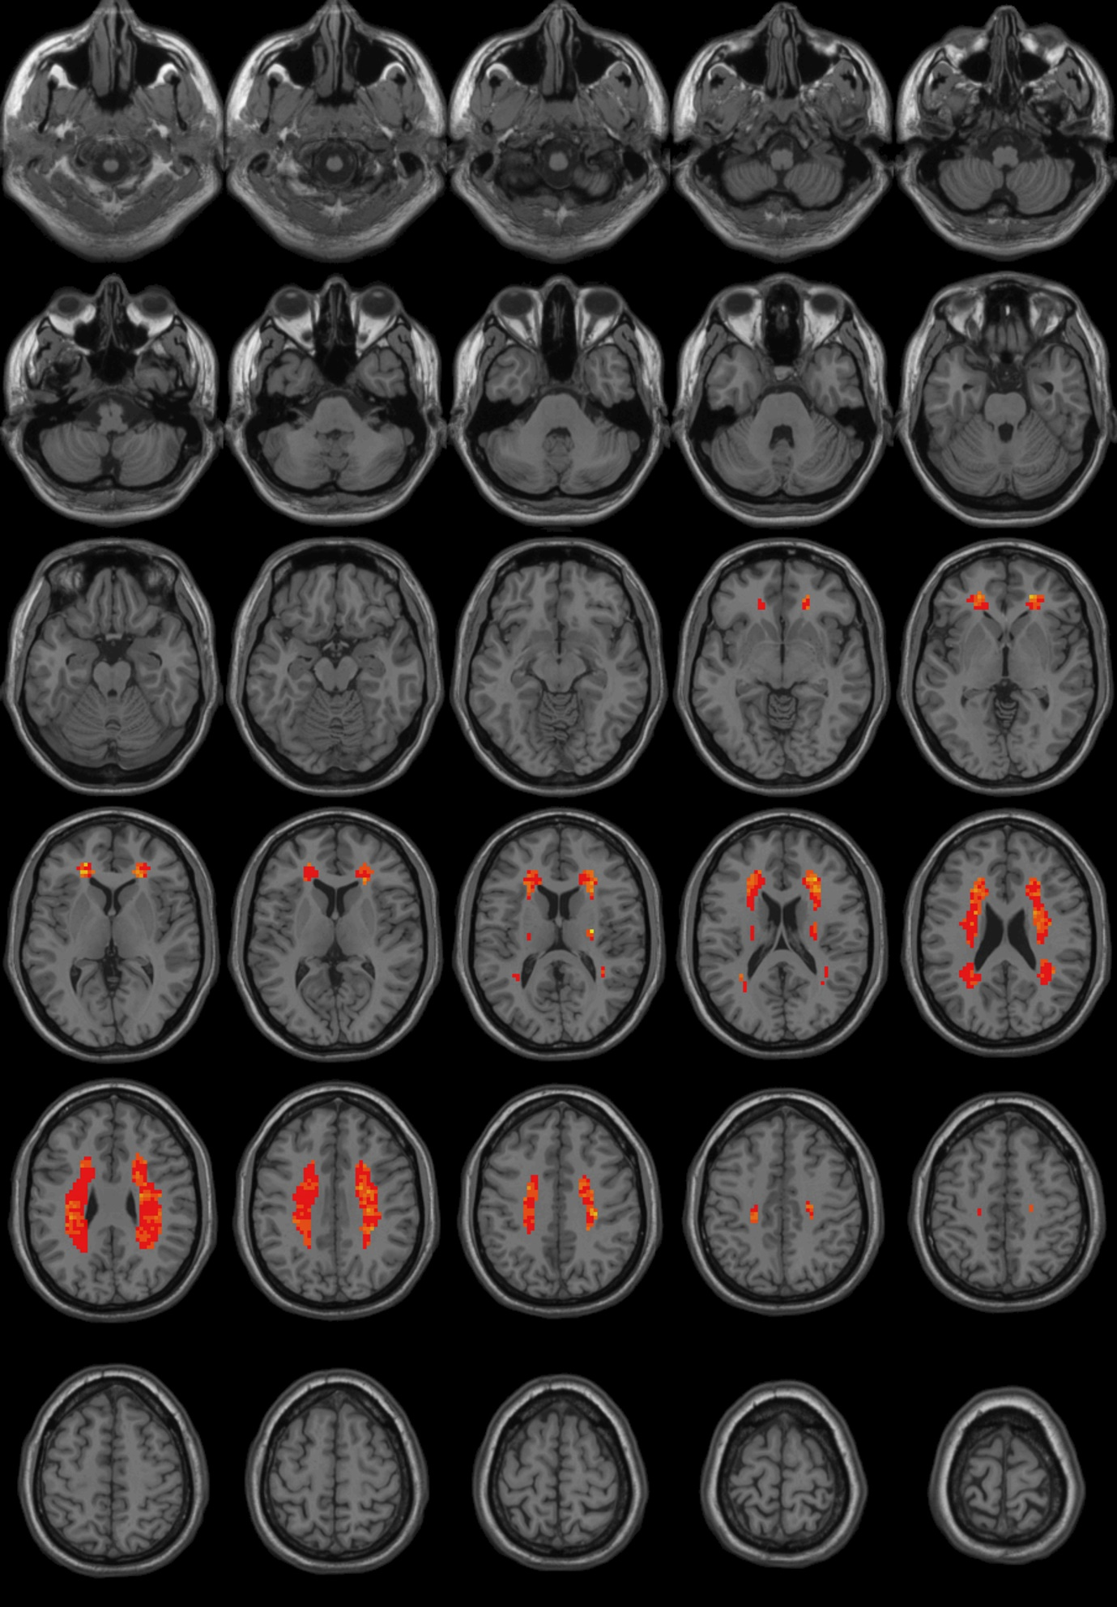

ReHO
Grpoup 1
Reading images from "C:\Users\gehan\Documents\BOLD\HCV\analysis\Results\ReHo_FunImgARCWF\ReHoMap_Sub001.nii" etc.

Image Files in the Group:
C:\Users\gehan\Documents\BOLD\HCV\analysis\Results\ReHo_FunImgARCWF\ReHoMap_Sub001.nii
C:\Users\gehan\Documents\BOLD\HCV\analysis\Results\ReHo_FunImgARCWF\ReHoMap_Sub0010.nii
C:\Users\gehan\Documents\BOLD\HCV\analysis\Results\ReHo_FunImgARCWF\ReHoMap_Sub002.nii
C:\Users\gehan\Documents\BOLD\HCV\analysis\Results\ReHo_FunImgARCWF\ReHoMap_Sub003.nii
C:\Users\gehan\Documents\BOLD\HCV\analysis\Results\ReHo_FunImgARCWF\ReHoMap_Sub004.nii
C:\Users\gehan\Documents\BOLD\HCV\analysis\Results\ReHo_FunImgARCWF\ReHoMap_Sub005.nii
C:\Users\gehan\Documents\BOLD\HCV\analysis\Results\ReHo_FunImgARCWF\ReHoMap_Sub006.nii
C:\Users\gehan\Documents\BOLD\HCV\analysis\Results\ReHo_FunImgARCWF\ReHoMap_Sub007.nii
C:\Users\gehan\Documents\BOLD\HCV\analysis\Results\ReHo_FunImgARCWF\ReHoMap_Sub008.nii
C:\Users\gehan\Documents\BOLD\HCV\analysis\Results\ReHo_FunImgARCWF\ReHoMap_Sub009.nii
C:\Users\gehan\Documents\BOLD\HCV\analysis\Results\ReHo_FunImgARCWF\mReHoMap_Sub001.nii
C:\Users\gehan\Documents\BOLD\HCV\analysis\Results\ReHo_FunImgARCWF\mReHoMap_Sub0010.nii
C:\Users\gehan\Documents\BOLD\HCV\analysis\Results\ReHo_FunImgARCWF\mReHoMap_Sub002.nii
C:\Users\gehan\Documents\BOLD\HCV\analysis\Results\ReHo_FunImgARCWF\mReHoMap_Sub003.nii
C:\Users\gehan\Documents\BOLD\HCV\analysis\Results\ReHo_FunImgARCWF\mReHoMap_Sub004.nii
C:\Users\gehan\Documents\BOLD\HCV\analysis\Results\ReHo_FunImgARCWF\mReHoMap_Sub005.nii
C:\Users\gehan\Documents\BOLD\HCV\analysis\Results\ReHo_FunImgARCWF\mReHoMap_Sub006.nii
C:\Users\gehan\Documents\BOLD\HCV\analysis\Results\ReHo_FunImgARCWF\mReHoMap_Sub007.nii
C:\Users\gehan\Documents\BOLD\HCV\analysis\Results\ReHo_FunImgARCWF\mReHoMap_Sub008.nii
C:\Users\gehan\Documents\BOLD\HCV\analysis\Results\ReHo_FunImgARCWF\mReHoMap_Sub009.nii
C:\Users\gehan\Documents\BOLD\HCV\analysis\Results\ReHo_FunImgARCWF\zReHoMap_Sub001.nii
C:\Users\gehan\Documents\BOLD\HCV\analysis\Results\ReHo_FunImgARCWF\zReHoMap_Sub0010.nii
C:\Users\gehan\Documents\BOLD\HCV\analysis\Results\ReHo_FunImgARCWF\zReHoMap_Sub002.nii
C:\Users\gehan\Documents\BOLD\HCV\analysis\Results\ReHo_FunImgARCWF\zReHoMap_Sub003.nii
C:\Users\gehan\Documents\BOLD\HCV\analysis\Results\ReHo_FunImgARCWF\zReHoMap_Sub004.nii
C:\Users\gehan\Documents\BOLD\HCV\analysis\Results\ReHo_FunImgARCWF\zReHoMap_Sub005.nii
C:\Users\gehan\Documents\BOLD\HCV\analysis\Results\ReHo_FunImgARCWF\zReHoMap_Sub006.nii
C:\Users\gehan\Documents\BOLD\HCV\analysis\Results\ReHo_FunImgARCWF\zReHoMap_Sub007.nii
C:\Users\gehan\Documents\BOLD\HCV\analysis\Results\ReHo_FunImgARCWF\zReHoMap_Sub008.nii
C:\Users\gehan\Documents\BOLD\HCV\analysis\Results\ReHo_FunImgARCWF\zReHoMap_Sub009.nii

Regression Calculating...
.........................................................................................................................DLH 0.040651 voxels^-3 before correcting for temporal DOF

FWHMx = 5.398708 voxels
FWHMy = 5.045410 voxels
FWHMz = 4.169348 voxels
FWHMx = 16.196124 mm
FWHMy = 15.136231 mm
FWHMz = 12.508045 mm
DLH = 0.041437
VOLUME = 1632
RESELS = 113.567610

Regression Calculation finished.

One Sample T Test Calculation finished.
This report is based on CUI Xu's xjview. (http://www.alivelearn.net/xjview/)
Revised by YAN Chao-Gan and ZHU Wei-Xuan 20091108: suitable for different Cluster Connectivity Criterion: surface connected, edge connected, corner connected.
Number of clusters found: 2
----------------------
Cluster 1
Number of voxels: 825
Peak MNI coordinate: 24 -51 36
Peak MNI coordinate region: // Right Cerebrum // Parietal Lobe // Sub-Gyral // White Matter // undefined // undefined
Peak intensity: 0.83318
# voxels structure
825 --TOTAL # VOXELS--
825 Right Cerebrum
823 White Matter
652 Sub-Gyral
613 Frontal Lobe
87 Parietal Lobe
79 Sub-lobar
75 Extra-Nuclear
34 Limbic Lobe
29 Cingulate Gyrus
24 Inferior Parietal Lobule
14 Precentral Gyrus
12 Temporal Lobe
9 Middle Frontal Gyrus
8 Postcentral Gyrus
6 Corpus Callosum
5 Anterior Cingulate
4 Insula
3 Superior Temporal Gyrus
2 Gray Matter
1 Medial Frontal Gyrus
1 Precuneus
1 brodmann area 13
1 brodmann area 9
1 Postcentral_R (aal)
----------------------
Cluster 2
Number of voxels: 807
Peak MNI coordinate: -15 27 15
Peak MNI coordinate region: // Left Cerebrum // Sub-lobar // Extra-Nuclear // White Matter // Corpus Callosum // undefined
Peak intensity: 0.91807
# voxels structure
807 --TOTAL # VOXELS--
807 Left Cerebrum
806 White Matter
647 Sub-Gyral
594 Frontal Lobe
91 Parietal Lobe
72 Sub-lobar
68 Extra-Nuclear
33 Limbic Lobe
25 Inferior Parietal Lobule
24 Cingulate Gyrus
17 Temporal Lobe
15 Precentral Gyrus
10 Corpus Callosum
8 Anterior Cingulate
8 Postcentral Gyrus
6 Middle Frontal Gyrus
4 Insula
1 Gray Matter
1 Superior Frontal Gyrus
1 brodmann area 32
1 Superior Temporal Gyrus

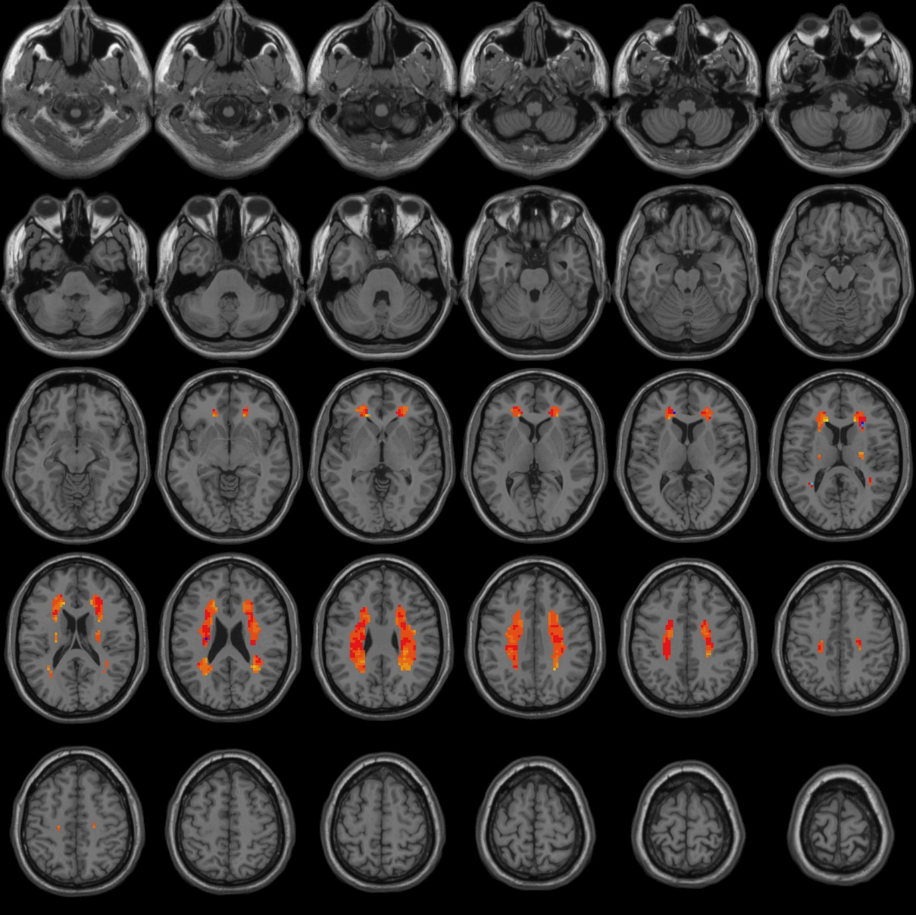

fALFF

Reading images from "C:\Users\gehan\Documents\BOLD\HCV\analysis\Results\fALFF_FunImgARCW\fALFFMap_Sub001.nii" etc.

Image Files in the Group:
C:\Users\gehan\Documents\BOLD\HCV\analysis\Results\fALFF_FunImgARCW\fALFFMap_Sub001.nii
C:\Users\gehan\Documents\BOLD\HCV\analysis\Results\fALFF_FunImgARCW\fALFFMap_Sub0010.nii
C:\Users\gehan\Documents\BOLD\HCV\analysis\Results\fALFF_FunImgARCW\fALFFMap_Sub002.nii
C:\Users\gehan\Documents\BOLD\HCV\analysis\Results\fALFF_FunImgARCW\fALFFMap_Sub003.nii
C:\Users\gehan\Documents\BOLD\HCV\analysis\Results\fALFF_FunImgARCW\fALFFMap_Sub004.nii
C:\Users\gehan\Documents\BOLD\HCV\analysis\Results\fALFF_FunImgARCW\fALFFMap_Sub005.nii
C:\Users\gehan\Documents\BOLD\HCV\analysis\Results\fALFF_FunImgARCW\fALFFMap_Sub006.nii
C:\Users\gehan\Documents\BOLD\HCV\analysis\Results\fALFF_FunImgARCW\fALFFMap_Sub007.nii
C:\Users\gehan\Documents\BOLD\HCV\analysis\Results\fALFF_FunImgARCW\fALFFMap_Sub008.nii
C:\Users\gehan\Documents\BOLD\HCV\analysis\Results\fALFF_FunImgARCW\fALFFMap_Sub009.nii
C:\Users\gehan\Documents\BOLD\HCV\analysis\Results\fALFF_FunImgARCW\mfALFFMap_Sub001.nii
C:\Users\gehan\Documents\BOLD\HCV\analysis\Results\fALFF_FunImgARCW\mfALFFMap_Sub0010.nii
C:\Users\gehan\Documents\BOLD\HCV\analysis\Results\fALFF_FunImgARCW\mfALFFMap_Sub002.nii
C:\Users\gehan\Documents\BOLD\HCV\analysis\Results\fALFF_FunImgARCW\mfALFFMap_Sub003.nii
C:\Users\gehan\Documents\BOLD\HCV\analysis\Results\fALFF_FunImgARCW\mfALFFMap_Sub004.nii
C:\Users\gehan\Documents\BOLD\HCV\analysis\Results\fALFF_FunImgARCW\mfALFFMap_Sub005.nii
C:\Users\gehan\Documents\BOLD\HCV\analysis\Results\fALFF_FunImgARCW\mfALFFMap_Sub006.nii
C:\Users\gehan\Documents\BOLD\HCV\analysis\Results\fALFF_FunImgARCW\mfALFFMap_Sub007.nii
C:\Users\gehan\Documents\BOLD\HCV\analysis\Results\fALFF_FunImgARCW\mfALFFMap_Sub008.nii
C:\Users\gehan\Documents\BOLD\HCV\analysis\Results\fALFF_FunImgARCW\mfALFFMap_Sub009.nii
C:\Users\gehan\Documents\BOLD\HCV\analysis\Results\fALFF_FunImgARCW\zfALFFMap_Sub001.nii
C:\Users\gehan\Documents\BOLD\HCV\analysis\Results\fALFF_FunImgARCW\zfALFFMap_Sub0010.nii
C:\Users\gehan\Documents\BOLD\HCV\analysis\Results\fALFF_FunImgARCW\zfALFFMap_Sub002.nii
C:\Users\gehan\Documents\BOLD\HCV\analysis\Results\fALFF_FunImgARCW\zfALFFMap_Sub003.nii
C:\Users\gehan\Documents\BOLD\HCV\analysis\Results\fALFF_FunImgARCW\zfALFFMap_Sub004.nii
C:\Users\gehan\Documents\BOLD\HCV\analysis\Results\fALFF_FunImgARCW\zfALFFMap_Sub005.nii
C:\Users\gehan\Documents\BOLD\HCV\analysis\Results\fALFF_FunImgARCW\zfALFFMap_Sub006.nii
C:\Users\gehan\Documents\BOLD\HCV\analysis\Results\fALFF_FunImgARCW\zfALFFMap_Sub007.nii
C:\Users\gehan\Documents\BOLD\HCV\analysis\Results\fALFF_FunImgARCW\zfALFFMap_Sub008.nii
C:\Users\gehan\Documents\BOLD\HCV\analysis\Results\fALFF_FunImgARCW\zfALFFMap_Sub009.nii

Regression Calculating...
.........................................................................................................................DLH 0.564246 voxels^-3 before correcting for temporal DOF

FWHMx = 1.929610 voxels
FWHMy = 1.995519 voxels
FWHMz = 2.124878 voxels
FWHMx = 5.788831 mm
FWHMy = 5.986556 mm
FWHMz = 6.374633 mm
DLH = 0.575147
VOLUME = 1632
RESELS = 8.181998

Regression Calculation finished.

One Sample T Test Calculation finished.
This report is based on CUI Xu's xjview. (http://www.alivelearn.net/xjview/)
Revised by YAN Chao-Gan and ZHU Wei-Xuan 20091108: suitable for different Cluster Connectivity Criterion: surface connected, edge connected, corner connected.
Number of clusters found: 2
----------------------
Cluster 1
Number of voxels: 825
Peak MNI coordinate: 24 -39 30
Peak MNI coordinate region: // Right Cerebrum // Frontal Lobe // Sub-Gyral // White Matter // undefined // undefined
Peak intensity: 3.8135
# voxels structure
825 --TOTAL # VOXELS--
825 Right Cerebrum
823 White Matter
652 Sub-Gyral
613 Frontal Lobe
87 Parietal Lobe
79 Sub-lobar
75 Extra-Nuclear
34 Limbic Lobe
29 Cingulate Gyrus
24 Inferior Parietal Lobule
14 Precentral Gyrus
12 Temporal Lobe
9 Middle Frontal Gyrus
8 Postcentral Gyrus
6 Corpus Callosum
5 Anterior Cingulate
4 Insula
3 Superior Temporal Gyrus
2 Gray Matter
1 Medial Frontal Gyrus
1 Precuneus
1 brodmann area 13
1 brodmann area 9
1 Postcentral_R (aal)
----------------------
Cluster 2
Number of voxels: 807
Peak MNI coordinate: -21 -51 24
Peak MNI coordinate region: // Left Cerebrum // Parietal Lobe // Sub-Gyral // White Matter // undefined // undefined
Peak intensity: 5.0456
# voxels structure
807 --TOTAL # VOXELS--
807 Left Cerebrum
806 White Matter
647 Sub-Gyral
594 Frontal Lobe
91 Parietal Lobe
72 Sub-lobar
68 Extra-Nuclear
33 Limbic Lobe
25 Inferior Parietal Lobule
24 Cingulate Gyrus
17 Temporal Lobe
15 Precentral Gyrus
10 Corpus Callosum
8 Anterior Cingulate
8 Postcentral Gyrus
6 Middle Frontal Gyrus
4 Insula
1 Gray Matter
1 Superior Frontal Gyrus
1 brodmann area 32
1 Superior Temporal Gyrus

